TITLE OF THE ABROAD EXPERIENCE REPORT

LAST NAME, First name (author 1); LAST NAME, First name (BENCH TUTOR, IF ANY);

LAST NAME, First name (supervisor at foreign institution; if any)
LAST NAME, First name (national advisor; if any)

e-mail@email.com (main author´s e-mail)
Identification of the foreign institution
Identification of the national institution

Keywords: Keyword 1; Keyword 2; Keyword 3, Keyword 4; Keyword 5. (from three to five)

- CONTEXT OF THE REPORT
In this space, describe where, when, duration, kind of activity, relevance and any aspect that contextualizes the activities performed abroad.

- DETAILS ACTIVITIES
Here, all activities developed will be described and detailed in chronological sequence, presenting their duration and interesting aspects about these activities.

- ANALYSIS AND DISCUSSION OF THE REPORT
As it is an academic scientific text, it is important that you relate your experience with a theoretical basis that complements it. Do not forget that only these authors should be cited in the References.
Whatever the type of illustration, its identification appears at the top, preceded by the designative word (picture, scheme, flowchart, graph, map, organization chart, portrait, figure, image, among others, such as the example of Figure x. After illustration, at the bottom, indicate the source consulted.

Figure X – Title
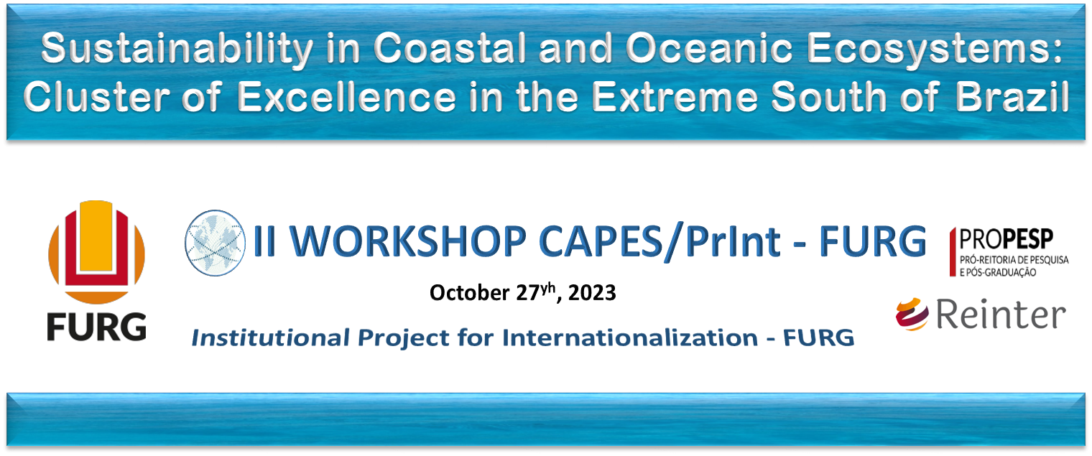
Source: The author(s).

The tables present statistically treated information and must be formatted according to ABNT NBR 14724 Academic Works – Presentation (2011).

Table 1- Title
COURSE | DATA
Course 1 | Data 1
Course 2 | Data 2
Course 3 | Data 3

- FINAL CONSIDERATIONS
Production of a synthesis of the learnings resulting from the developed activities. This synthesis should be produced in response to questions such as: How can this experience contribute to your future studies or professional activities? Did you find difficulties during this experience? If so, could you please briefly describe, indicating how they were solved or dealt with? And if everything went well, tell us about that experience in detail. What was the learning from this experience?

5 REFERENCES (Only papers or books cited in the abstract of the experience report should be listed. See ABNT NBR 6023 References – Elaboration (2002)).

SURNAME, First name. Títle: subtitle. Edition. Location: Publisher, year of publication. Page n. (Book)
SURNAME, First name. Title of the paper. Journal Name. volume, issue, initial and final page, year. Available at: <www.site.com>. Accessed on 1st March, 2023. (Journal)

Important: The abstract must have 2 to 4 pages.

